Luz Deloria

Lab 6 - MAC/ARP

10/29/2018

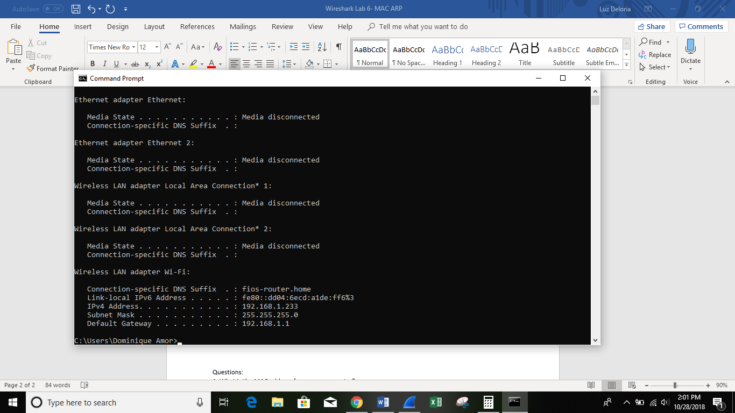

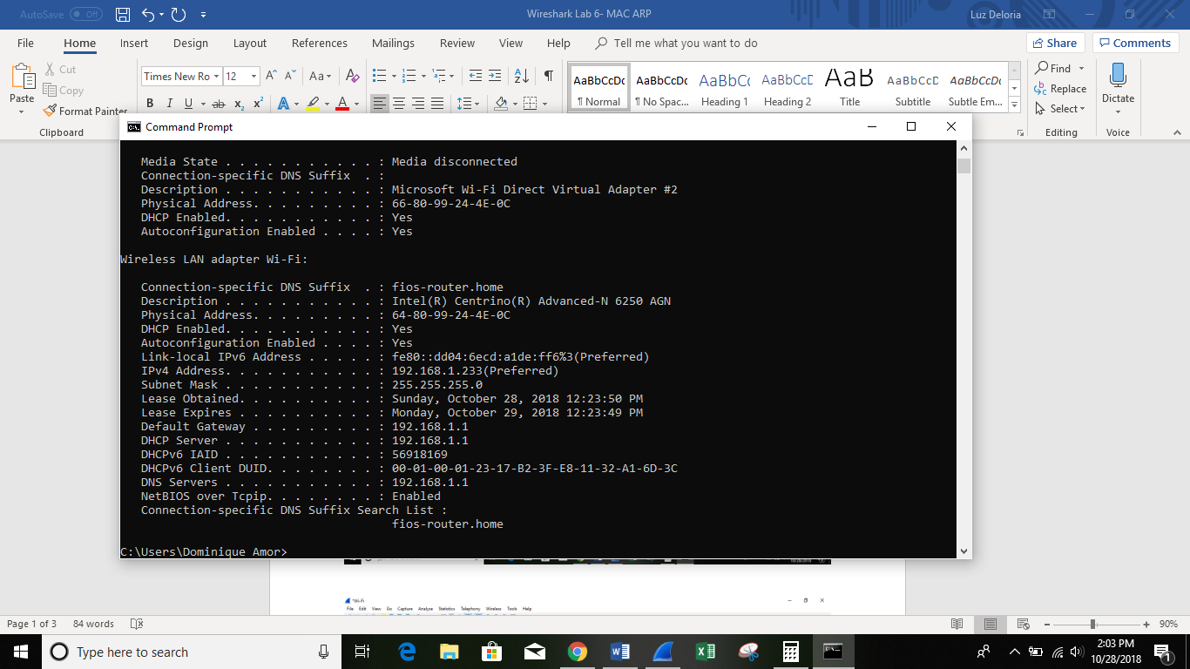

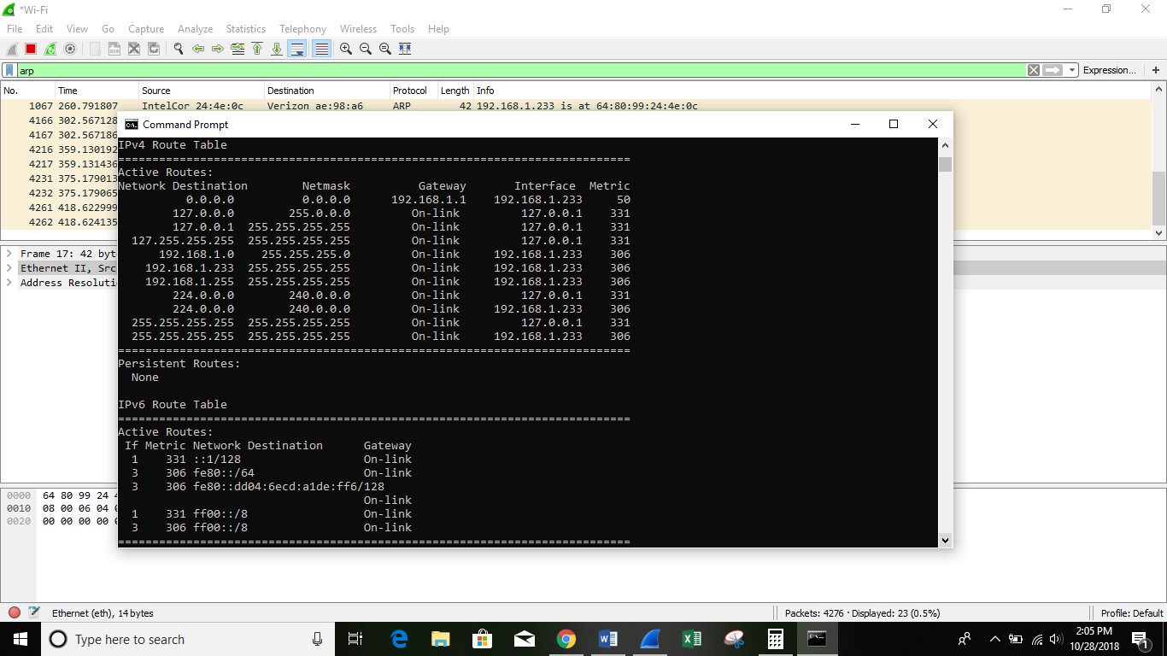

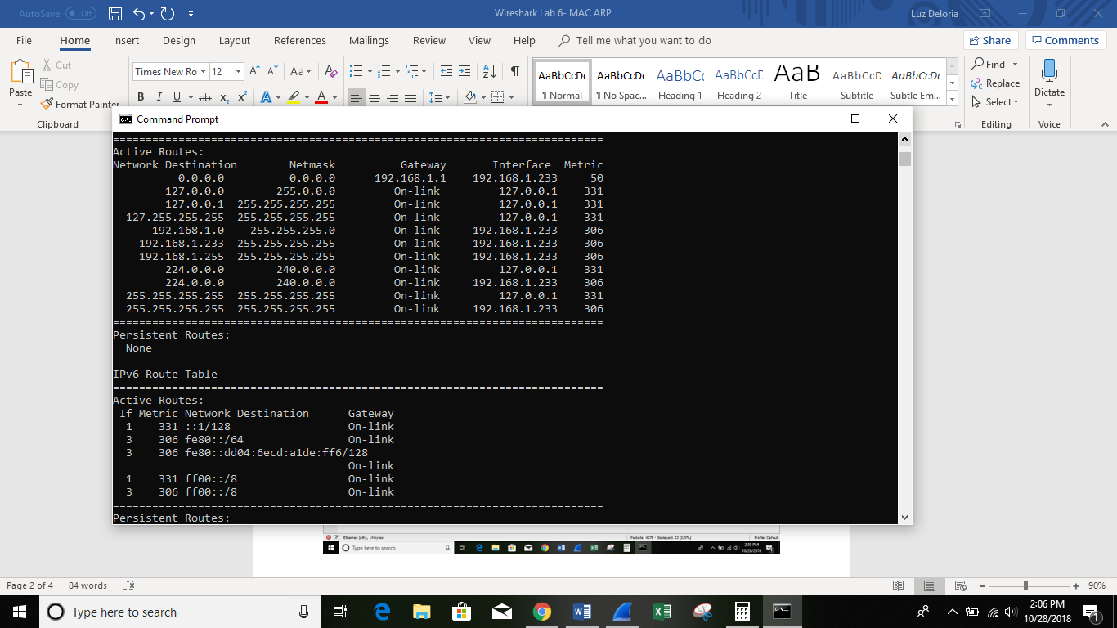

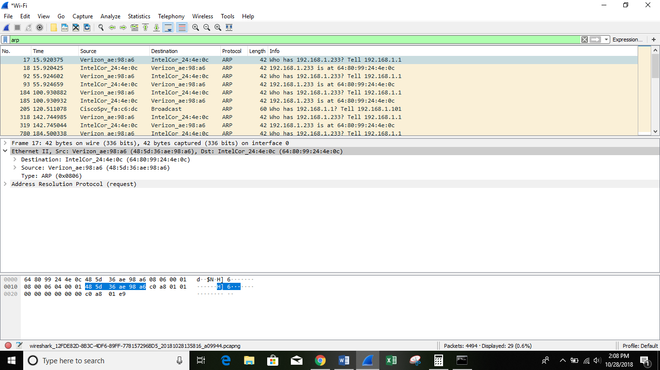

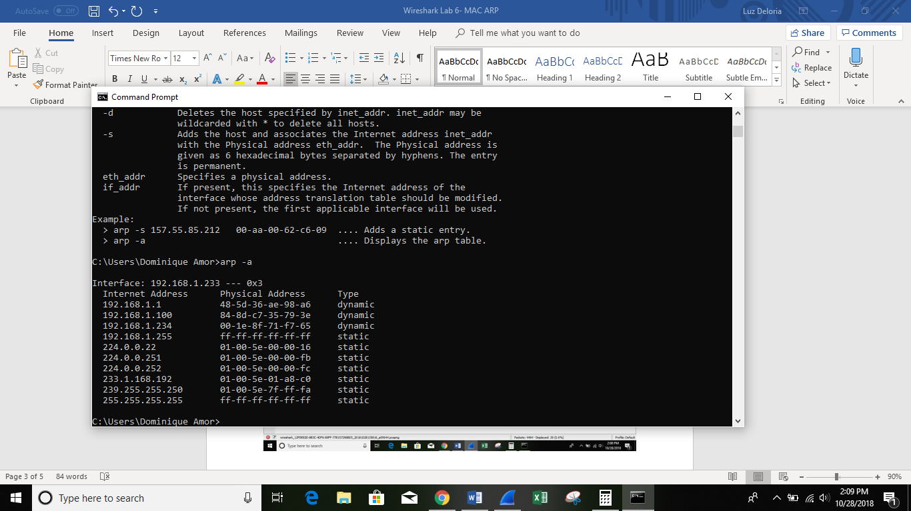

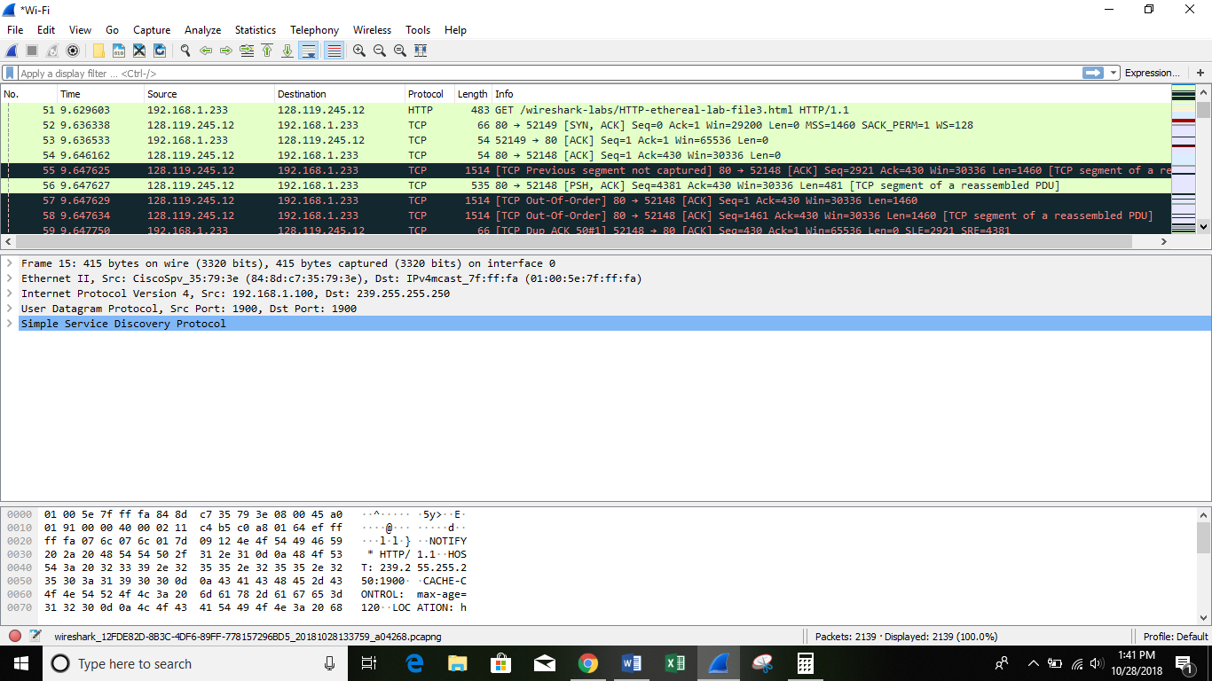

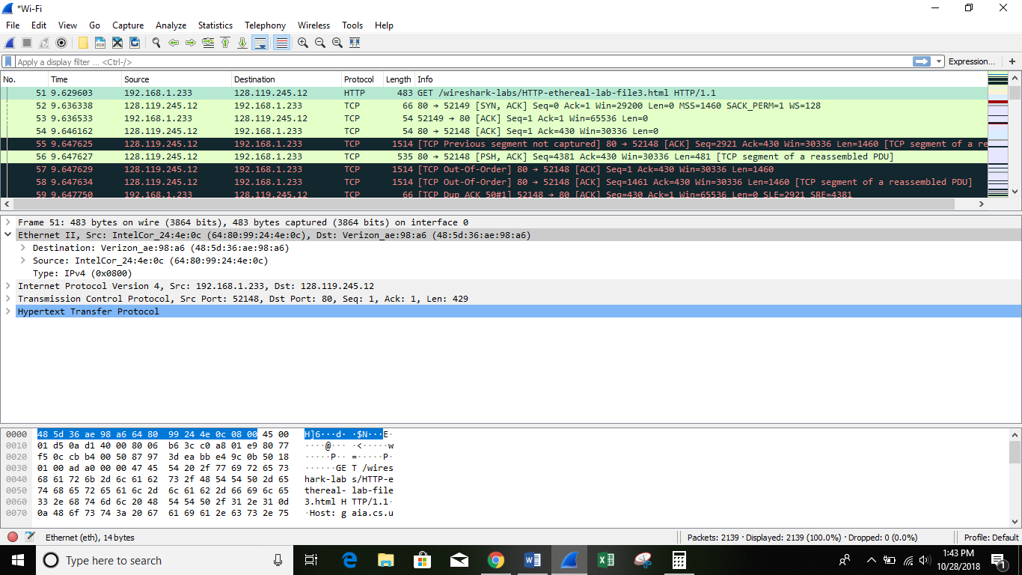

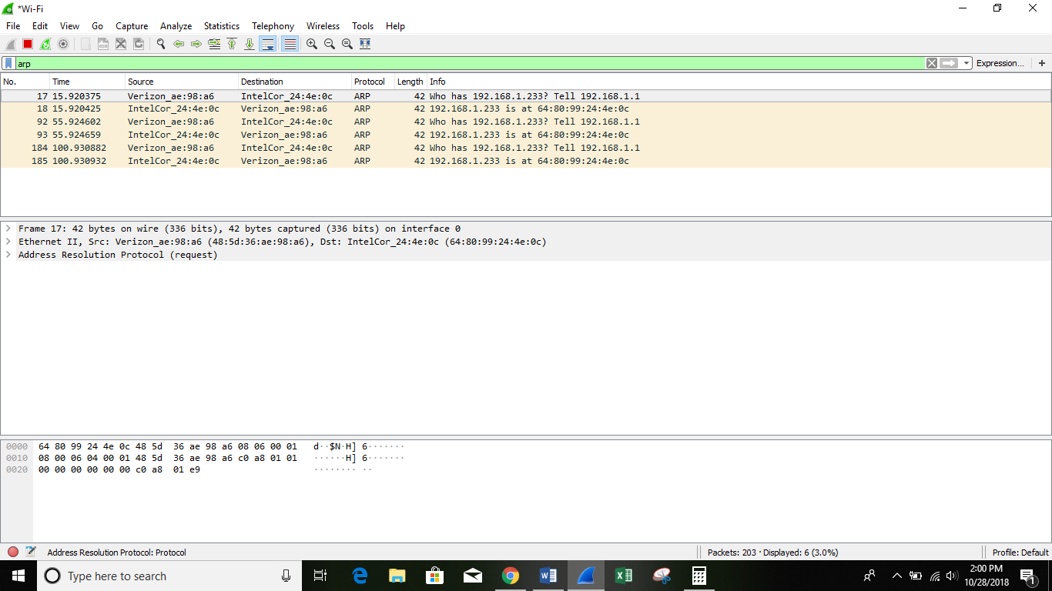

Questions:

1. What is the MAC address from your computer?

2. What is the destination MAC address?

3. What device has the MAC address shown in the destination?

4. Explain the relationship between the destination MAC address and the destination IP address.

5. Using the terminal (cmd in Windows, Terminal in mac), run a command to display your full ARP list table. (Find out what the command is, and print a full screen shot of your result.)